**Getting the script on the computer**

1. 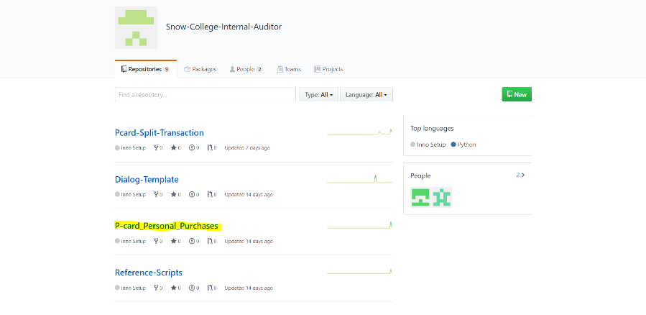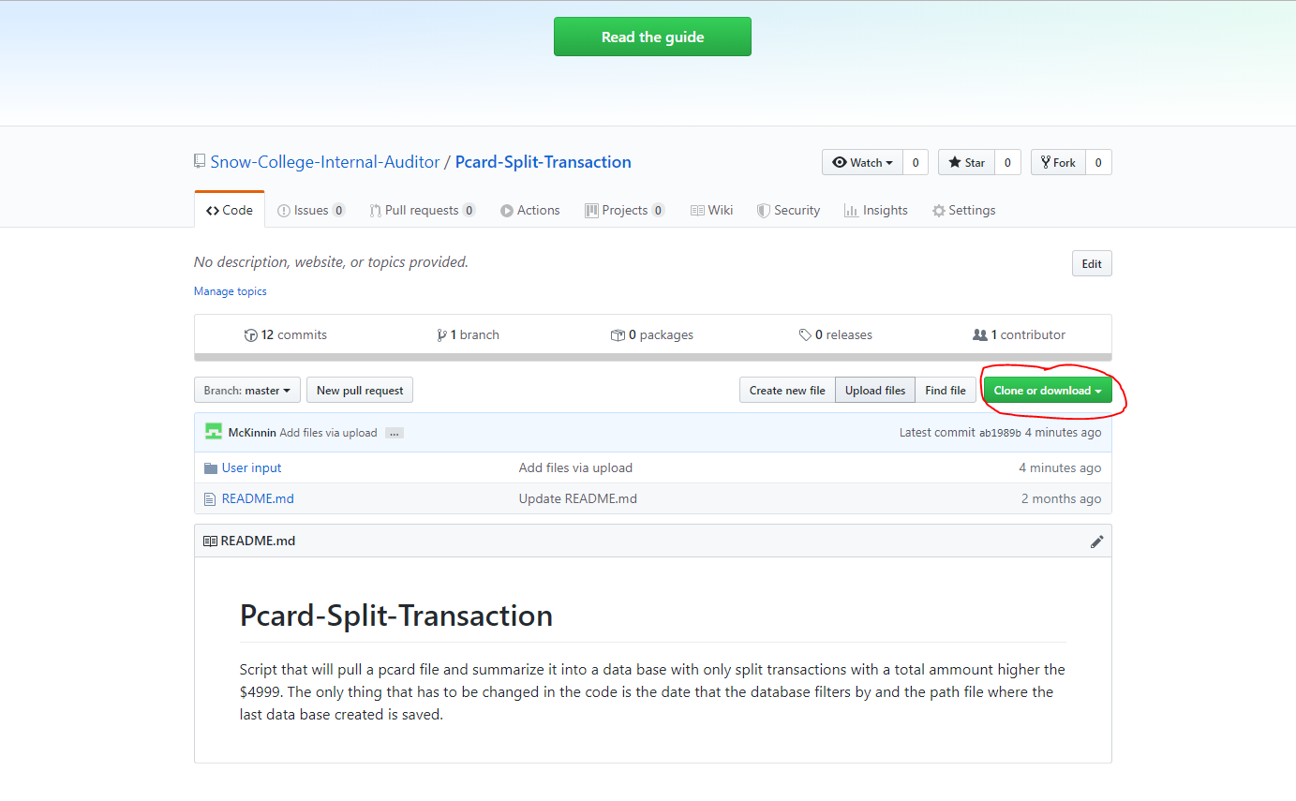 The first thing we need to do is get the program on your computer. Follow this link, <https://github.com/Snow-College-Internal-Auditor>, to GitHub. On this page you will see multiple scripts for the Audit department. The one you are interested in is P-card_Personal_Purchases. Note this might not be the third one from the top.
2. Once you find the link click on it and it will take you to the repository for the IDEA script. On this page you will see a file and a read me document. The read me section is a short description of what this script does. The file called “individual Scripts” Has all the individual IDEA scripts for the different test that. You will download these, but most likely won’t use them. At this point all you have to do is click on the green button on the right of the screen.
3. Once you click on the button click “Download Zip”. This will put all of the files on your computer.
4. Once this has downloaded go to your download folder and find this file. When this file has been located right click it and look for the command “Extract All…”. This will open up a dialog box that asks for where you want to extract the to. Select where you would like to have the file saved, it does not matter where, once this is done navigate to that location on your computer.

**Binding the script to IDEA**

1. 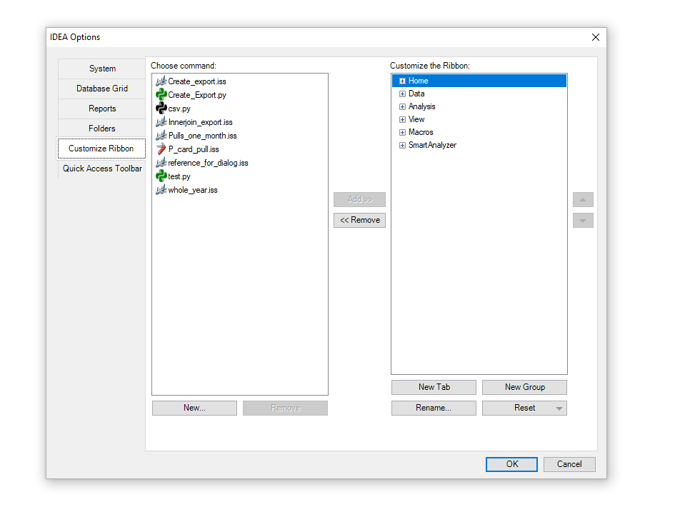 What we will be doing now is adding the two scripts to your task bar in IDEA. Once in IDEA you will want to click on the “Macros” tab. Now click on the button that says “Bind to Ribbon”. You should see this screen open.
2. What you’re going to do here is decided where you want the script to be located in your tool bar. It does not matter where you place the script. There are two ways you can do this. You can create tab, like home, data, etc., or you can create a new group in one of the tabs.
   1. Creating a new tab:
      1. 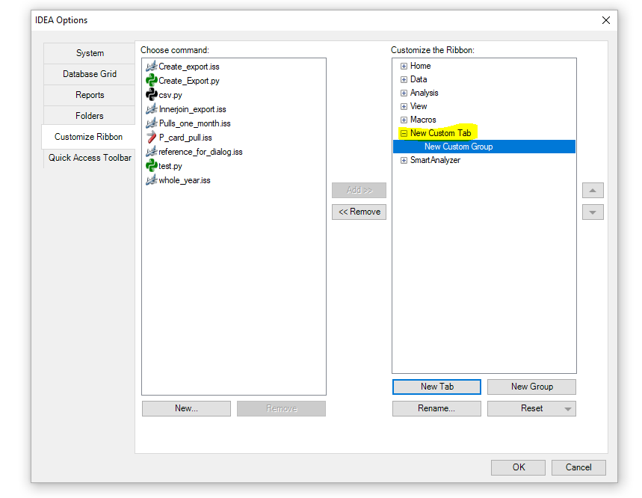For creating a new tab simply click the button on the bottom right of the IDEA Options screen called, “New Tab”.
      2. This will create a new tab in the Customize the Ribbon section. You can rename this tab by clicking the Rename button at the bottom right side of the screen.
   2. Creating a new group:
      1. 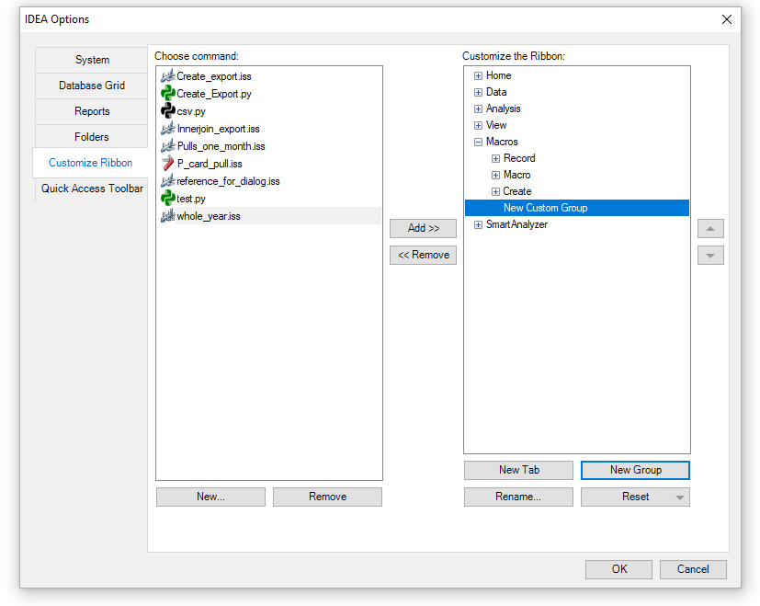Click what tab you want to add a new group to. Again, the tab you use is your decision.
      2. Once on the tab of your choice click the New Group button at the button right of your screen. This should add a new group under the selected tab. You can rename this group by clicking the Rename button at the bottom right side of the screen.
3. Once you have your new tab or group you need to add the script to the “Choose command” section of the screen. To do this click the “New…” button at the bottom left of the screen.
4. 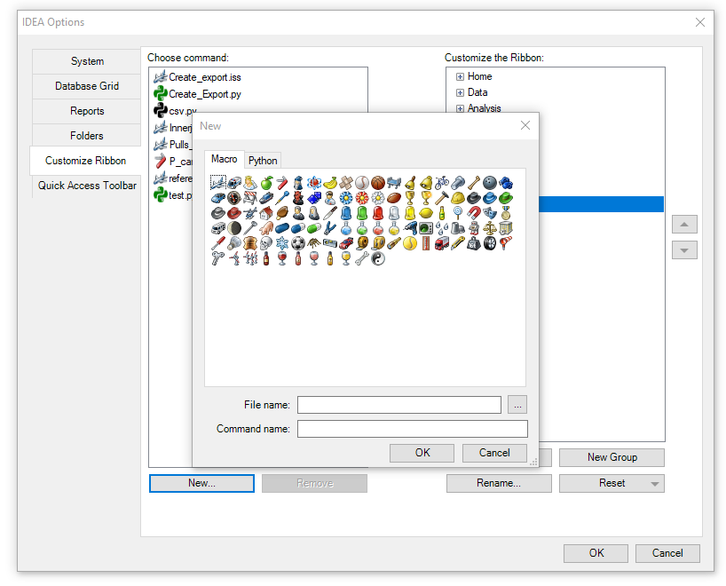Before locating the file in your computer, you must select an icon for the script. If you are adding an IDEA Script file then you must select an icon from the Macro section. If your adding a python script you must select an icon from the Python selection. It does not matter which icon you decided on. Only that you select from the correct group.
5. 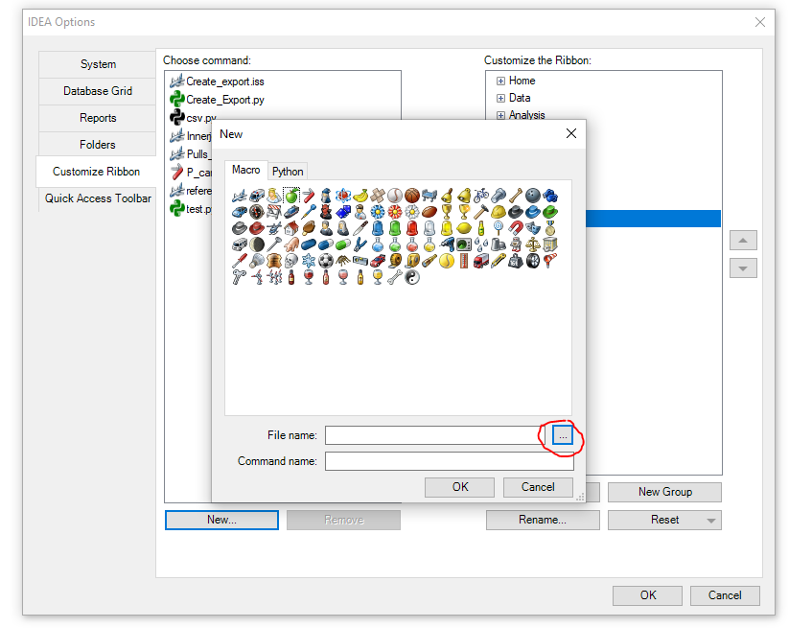To locate the file on your computer, click the button with the three dots at the end of “File Name.”
6. Now locate the script on your computer and click open. This should add the script at the bottom of the Choose command section.
7. 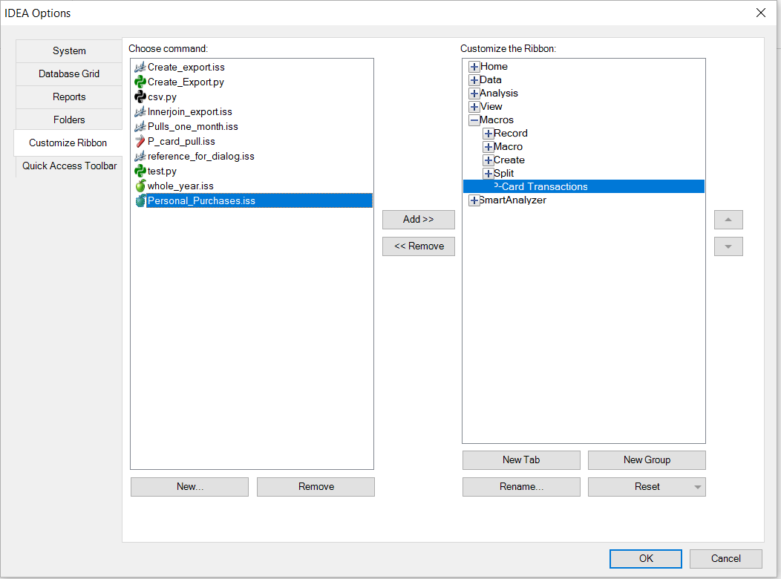Now you will click on the tab or group that you want to add the script to. Once the tab/group is selected select the script so that the both are highlighted.
8. Once you have both of them highlighted click the button in the middle of the screen that says, “Add >>”. This is should add the script to that tab/group.
9. 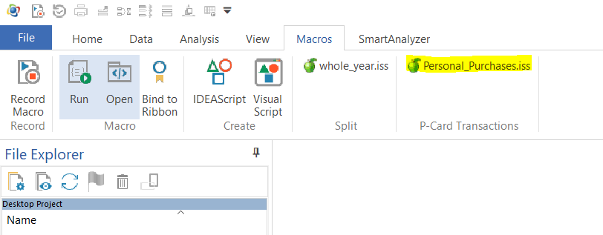If this is done correctly you should have the new script under the tab/group you selected as well as it should appear in the tool bar in IDEA.
10. At this point you should be able to click on the script in the tool bar and have it run in IDEA. Though depending on the date being audited you might have to make some changes to the code.

**Running the Code**

1. To run the script either go to the tab in IDEA where you have the script saved to your tool bar and click that.
2. First the script will ask you to input the month you are comparing the last year to. Enter in the name of the month, it does not matter how long you make it, then click OK
3. You then will be prompted to select the starting file. Navigate to the location of the file you want to pull.
4. 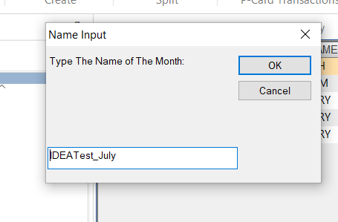The program will start running. Before ending another dialog box will appear asking for the name for the new file. Input a name or use the default name, if it is not already being used.
5. 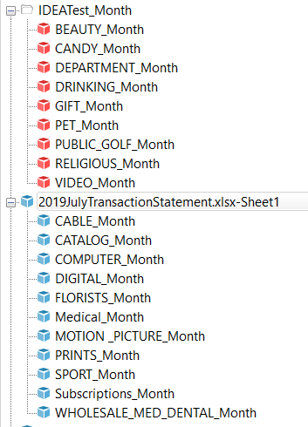The new file you created will hold all of the sub-databases that had no information in them. Your file explorer on the side should have the database for the month or year you pulled in, with the sub-databases that had data, and the new folder with the empty sub-databases.